**Title:** Analyzing and comparing long-term water quality of lakes and reservoirs in Rhode Island and the Northeastern United States using an anomaly approach

*1* US Environmental Protection Agency, Office Of Research and Development, Atlantic Coastal Environmental Sciences Division, Narragansett, RI 02882

*2* University of Rhode Island, Department of Natural Resources Science, Kingston, RI 02881

*3* ORISE, Narragansett, RI 02882

**Authors:** Hollister. J. W. * *1*, Kellogg, D. Q. *2*, Kreakie, B. J. *1*, Shivers, S. *3*, Milstead, W. B. *1*, Herron, E. *2*, Green, L. *2*, Gold, A. *2*

**Corresponding author:** [**hollister.jeff@epa.gov**](mailto:hollister.jeff@epa.gov)

**Abstract:** Addressing anthropogenic impacts on aquatic ecosystems is a focus of lake management. Controlling phosphorus and nitrogen can mitigate these impacts, but determining management effectiveness requires long-term datasets. Recent analysis of the LAke multi-scaled GeOSpatial and temporal database for the Northeast (LAGOSNE) United States found stable water quality in the northeastern and midwestern United States, however, sub-regional trends may be obscured. We analyze a sub-regional (i.e., 3000 km2) trend with the University of Rhode Island’s Watershed Watch Volunteer Monitoring Program (URIWW) dataset. URIWW has collected water quality data on Rhode Island lakes and reservoirs for over 25 years. The LAGOSNE and URIWW datasets allow for comparison of water quality trends at regional and sub-regional scales, respectively. We assess regional (LAGOSNE) and state (URIWW) trends with yearly median anomalies calculated on a per-station basis. Sub-regionally, temperature and chlorophyll *a* increased from 1993 to 2016. Total nitrogen shows a weak increase driven by low years in the early 1990s. Total phosphorus and the nitrogen:phosphorus ratio (N:P) were stable. At the regional scale, the LAGOSNE dataset shows similar trends to prior studies of the LAGOSNE with chlorophyll *a*, total nitrogen, total phosphorus, and N:P all stable over time. In short, algal biomass, as measured by chlorophyll *a* in Rhode Island lakes and reservoirs is increasing, despite stability in total nitrogen, total phosphorus, and the nitrogen to phosphorus ratio. This analysis suggests an association between lake temperature and primary production. Additionally, we demonstrate both the value of long-term monitoring programs, like URIWW, for identifying trends in environmental condition, and the utility of site-specific anomalies for analyzing for long-term water quality trends.  
**Keywords:** Volunteer Monitoring, Citizen Science, Nutrients, Lakes, Trend Analysis, Long Term

# Introduction

Aquatic ecosystems have been altered as the result of human activities modifying nutrient cycling on a global scale (Vitousek et al. 1997, Filippelli 2008, Finlay et al. 2013). Because of their position in the landscape, lakes can function as integrators and sentinels for these anthropogenic effects (Williamson et al. 2008, Schindler 2009). Increasing nutrient inputs, particularly of nitrogen (N) and phosphorus (P), derived from intensive agriculture and densely populated urban areas have contributed to the eutrophication of many lakes (Carpenter et al. 1998, Smith 2003). This eutrophication often leads to an increase in the frequency and severity of harmful algal blooms, greater risks for human and animal health, and potential economic costs associated with eutrophic waters (Dodds et al. 2008, Paerl and Huisman 2009, Kosten et al. 2012, Michalak et al. 2013, Taranu et al. 2015, Brooks et al. 2016). To address these problems, management strategies have historically focused on reducing P inputs to lakes, but research also suggests that reducing N inputs may be more effective in certain situations (Schindler et al. 2008, Paerl et al. 2016). These studies indicate that relationships between N, P, and chlorophyll *a* exist and these relationships are spatially and temporally complex. Thus, long-term data are needed to identify trends at local, regional, and national scales.

Lake datasets that cover longer time periods and broader spatial scales are now becoming available. Programs such as the US Environmental Protection Agency’s National Lakes Assessment (NLA) provide data that allow for continental-scale water quality analysis. These data allow for analyses that can be useful for managing water resources by developing water quality criteria for N, P, and chlorophyll *a* (Herlihy et al. 2013, Yuan et al. 2014). Studying temporal trends across large spatial scales can illustrate the effects of eutrophication such as the degradation of oligotrophic systems as P increases (Stoddard et al. 2016). Broad-scale data can also be used for water quality modeling across a range of spatial scales including for predicting lake trophic state, which is indicative of ecosystem condition (Hollister et al. 2016, Nojavan et al. 2019). These trophic state models indicate that landscape variables (e.g., ecoregion, elevation, and latitude) are important and that regional trends exist. Lake-specific drivers have also been shown to be important for predicting continental-scale water quality which adds an additional layer of complexity (Read et al. 2015). Despite these challenges, it is important to study lakes at multiple spatial scales because emergent trends on regional or continental scales may or may not be present in individual lakes (Cheruvelil et al. 2013, Lottig et al. 2014).

Previous studies using regional data from the northeastern and midwestern United States (US) have investigated spatial and temporal water quality trends and have shown differences based on scale. Macro-scale (i.e., ~ 1,800,000 km 2) drivers of water quality trends are complex and may vary temporally (Lottig et al. 2017). This complexity can cause nutrient (N and P) trends to have different drivers than ratios of the nutrients (Collins et al. 2017). On a regional scale, trends of N, P, and chlorophyll *a* differ as factors such as land use and climate vary between regions, particularly when comparing the northeastern (i.e. ~400,000 km2) and midwestern (i.e. ~1,000,000 km2) US regions (Filstrup et al. 2014, 2018). Furthermore, little change in nutrients and chlorophyll *a* was reported over a 25 year period for these regions (Oliver et al. 2017). Given what is known about long-term trends in water quality within the broader regions of the northeastern and midwestern United States (US), we were curious if the lack of trends was also present in water quality at a sub-regional scale, using data on the 3,000 km2 area that encompasses a number of Rhode Island lakes and reservoirs.

Examining long-term trends in Rhode Island lakes is possible because of the data gathered by University of Rhode Island’s Watershed Watch (URIWW). URIWW is a scientist-led citizen science program founded in the late 1980s that has built a robust collaboration between URI scientists and a vast network of volunteer monitors. Volunteer monitors are trained and then collect *in situ* data as well as whole water samples during the growing season (e.g., May through October). The entire effort follows rigorous quality control/quality assurance protocols. These types of citizen science efforts allow for the collection of reliable data that in turn lead to crucial and frequently unexpected insights (Dickinson et al. 2012, Kosmala et al. 2016, Oliver et al. 2017). URIWW data contributed to the larger regional study by Oliver et al. (2017), and, also allowed us to examine the long-term trends specifically in Rhode Island.

The goals of this study were to examine ~25 years of lake and reservoir data in Rhode Island and answer two questions. First, are there state-wide trends in total nitrogen (TN), total phosphorus (TP), total nitrogen to total phosphorus ratio (TN:TP), chlorophyll *a*, and lake temperature? Second, are water quality trends in Rhode Island similar to regional trends in the northeastern United States? Another objective of this paper was to apply existing methods for examining long-term climate records (e.g., Jones and Hulme 1996) to water quality data in order to examine long-term trends. We conducted this analysis using open data from the URI Watershed Watch program and the LAke multi-scaled GeOSpatial and temporal database for the Northeast (LAGOSNE) project and the analysis in its entirety is available for independent reproduction at <https://github.com/usepa/ri_wq_trends> and is archived at <https://doi.org/10.5281/zenodo.3662828> (Soranno et al. 2017, 2019, Stachelek and Oliver 2017, Hollister et al. 2019).

# Methods

## Study Area and Data

The study area for this analysis includes lakes and reservoirs in the state of Rhode Island where data were collected by the University of Rhode Island’s Watershed Watch program (Figure 1). The URIWW program began in 1988, monitoring 14 lakes and has now grown to include over 250 monitoring sites on over 120 waterbodies, including rivers/streams, and estuaries, with more than 400 trained volunteers. URIWW now provides more than 90% of Rhode Island’s lake baseline data and is an integral part of the state’s environmental data collection strategy. Data quality assurance and control is treated with paramount importance; volunteers are trained both in the classroom and the field, regular quality checks occur, and volunteers are provided with all the necessary equipment and supplies, along with scheduled collection dates. For freshwater lakes and reservoirs, weekly Secchi depth and water temperature are recorded, along with bi-weekly chlorophyll *a* and in deep lakes (greater than 5 meters) dissolved oxygen. Water samples are collected three times per season (May through October) to be analyzed for nutrients and bacteria.

For this analysis, we were interested in trends in lake temperature, TN, TP, TN:TP, and chlorophyll *a*. In particular, we selected URIWW sites that matched the following criteria: 1) were sampled between 1993 and 2016, 2) were sampled in May to October, 3) had at least one sampling event in each of May/June, July/August, and September/October, 4) had at least one sampling event from 1993-2004 and 2005-2016, 5) and were sampled at a depth of 2 meters or less. As not all sites have data for all selected years, we further filtered the data to select sites that had at least 10 years of data for a given parameter within the 1993 to 2016 time frame. The final dataset used in our analysis included 60 lakes and reservoirs. Of these sites, our filtered dataset had 58 sites measured for temperature, 58 sites measured for chlorophyll *a*, 54 sites measured for TN, and 55 sites measured for TP. Of the 60 sampling sites, 51 had data for all 5 parameters. The N:P ratio was calculated by dividing the mass concentrations of total nitrogen and total phosphorus and then converting to a molar ratio by multiplying by 2.21 (e.g., atomic weight of P 30.974/atomic weight of N 14.007).

Field and analytical methods are detailed on the URIWW website at <https://web.uri.edu/watershedwatch/uri-watershed-watch-monitoring-manuals/> and <https://web.uri.edu/watershedwatch/uri-watershed-watch-quality-assurance-project-plans-qapps/>, respectively. These methods, approved by both the state of Rhode Island and the US Environmental Protection Agency, have remained fairly consistent, although over the nearly 30 years changes did occur. When new methods were introduced, comparisons between old and new methods were conducted and in all cases no statistically significant differences were found with the new methods. Furthermore, the new methods did at times improve the limits of detection; however, this impacted a very small number (less than 1%) of measurements in this study. We did run our analyses (see **Water Quality Trend Analysis** section) with all data and with only those data greater than the detection limit. There was no change in the trend analysis and thus, the results we report are for all data as originally reported in the URIWW dataset. Given these results, we assume the data to be consistent across the reported time period and appropriate for a long term assessment of trends.

Prior studies have modeled water quality trends across a larger region of the northeastern US that included 17 states including Minnesota, Wisconsin, Iowa, Missouri, Illinois, Indiana, Michigan, Ohio, Pennsylvania, New York, New Jersey, Connecticut, Massachusetts, Rhode Island, Vermont, New Hampshire, and Maine (Soranno et al. 2015, Oliver et al. 2017). We repeated our analysis (see **Water Quality Trend Analysis** section) with the same dataset used by Oliver et al. (2017), the LAGOSNE dataset (Soranno et al. 2015, 2017, 2019, Stachelek and Oliver 2017). Temperature data were not available, thus we examined trends, using our analytical methods, for TN, TP, TN:TP, and chlorophyll *a* from the LAGOSNE dataset. We used the same selection criteria on the LAGOSNE dataset as was applied to the URIWW data. This ensured that both datasets represented the same seasonal time frame. Exact measurement depth for the LAGOSNE data were not available; however, the water quality data are reported to be either surface or epilimnion samples (Soranno et al. 2017). At this time, the LAGOSNE data do not extend beyond 2013 thus sites needed to have a sampling event in 1993-2002 and in 2003-2013.

Lastly, to facilitate a comparison of the context of each scale, we use data, also from LAGOSNE, on landscape composition, maximum lake depth, and lake area (Soranno et al. 2017). We use the 500 meter buffer landscape composition for three classes from the 2011 National Land Cover Dataset: Agriculuture, Forest, and Developed. The maximum lake depth is from various sources and lake area is calculated from the National Hydropgraphy Dataset waterbody polygons. Additional details are available in are detailed in Soranno et al. (2017).

## Water Quality Trend Analysis

There are many different methods for analyzing time series data for trends. Environmental data are notoriously “noisy” and one of the difficulties that is encountered with multiple sampling locations is how to identify a trend while there is variation within a sampling site as well as variation introduced by differing start years for sampling among the many sites. For instance, if long-term data on water quality were collected more frequently in early years from more pristine waterbodies, then a simple comparison of raw values over time might show a decrease in water quality, which could be misleading if later sampling occurred on both pristine and more eutrophic water bodies. Thus, it is necessary to account for this type of within-site and among-site variation, using methods similar to those used to analyze long-term temperature trends using temperature anomalies (e.g., Jones and Hulme 1996). The general approach we used calculates site-specific deviations from a long-term median over a pre-determined reference period. This is slightly different than the typical use with temperature anomalies as those usually use the mean instead of the median. Many of the variable we looked at are non-normal and often have outliers (e.g. algal blooms). In this case the median is preferred. Using the median with site-specific deviations allows all sites to be shifted to a common baseline and the deviations, or anomalies, indicate change over the specified reference period. We refer to this method as “site-specific anomalies”.

*Summarizing site-specific anomalies:* Methods for calculating the site-specific anomalies and the yearly medians are as follows and are presented graphically in Figure 2. Additionally, an example R script, schematic_anomaly.R and example dataset, schematic.csv to recreate and demonstrate the calculations in Figure 2 is available from at <https://github.com/usepa/ri_wq_trends> and is archived at <https://doi.org/10.5281/zenodo.3662828> (Hollister et al. 2019).

The general steps, outlined in Figure 2 and listed below, are repeated for each of the water quality parameters.

1. For each site, calculate the annual medians, producing a single median value for each site and year. This step prevents bias from pseudoreplication of multiple measurements of the same site in a given year (Hurlbert 1984). The per site medians across years are assumed to be independent.
2. Calculate the long-term reference median for each site. This results in a single long-term median for each of the sites.
3. Calculate the anomaly for each annual median at each site by subtracting the annual and reference medians.
4. Summarize by calculating the median anomaly per year for the entire group of sites. The resultant values are analyzed for a trend over time.

After filtering and summarizing the data some years may not have sufficient number of sites to be included. We chose to include years in the analysis if they had at least three sites, but years with small numbers of sites are rare and only occurred with the nutrient data very early in the time frame of our analysis for the URIWW data(Table 1) and late in the time frame for the LAGOSNE data (Table 2).

*Linear regression on annual median anomalies:* Testing for a regression slope being different than zero can be used to test for monotonic trends in water quality data (Helsel and Hirsch 2002). We used these standard procedures to test for positive or negative trends in lake temperature, chlorophyll *a*, TN, TP and TN:TP. For each parameter, we fit a regression line to the anomalies as a function of year and tested the null hypothesis that no trend existed (e.g., 1 = 0). The slope of this line provides information on the average yearly change of that parameter over the time period studied.

*Assessing regressions for trends:* Traditionally, trends would be determined by assessing “significance” but recent guidelines suggest not using arbitrary p-value cut-offs to assesses significance (Wasserstein et al. 2016). Our interpretation of the trends attempts to follow this advice and we assess trends with multiple lines of evidence. For this assessment, we are defining a trend as with the following: 1) p-values are used to determine general levels of statistical support, 2) relative frequency of high and low years in the beginning and end of the time frame suggest an increasing or decreasing patter, and 4) the magnitude of the slope is used to infer an ecologically relevant change. Using all of this information we determine that a trend exists if it meets at least 2 of the 3 criteria, a weak trend exists if it meets one of the criteria and no trend exists if it meets none of the criteria.

We recognize that ecologically relevant change is system dependent and no single value will be universally appropriate. We are using several values for this particular assessment, but other values could also be justified. There are various ways to identify important temperature changes in lakes and reservoirs. A policy based approach could examine agreements that attempt to limit temperature increases, such as the Paris Agreement, which aims to limit increases over the next century to 2°C, which would be 0.02°C per year and similarly, the state of Rhode Island criteria for temperature increase is 2.2°C or 0.022°C per year over a century (2010, “Paris agreement” 2015). Alternatively, we could look at more ecologically focused temperature changes. For instance, Winder and Schindler (2004) saw disrupted trophic linkages between phytoplankton and zooplankton with 1.39°C over a 40 year data set, or 0.035°C per year. For this study, we will use the 0.02°C per year as it would provide protections against other ecologically relevant changes (e.g. 0.035°C per year for trophic linkages), meet local criteria, and would also be indicative of meeting an important policy goal. For changes in chlorophyll, total phosphorus, and total nitrogen an ecologically meaningful trend is one that would result in a change from an oligotrophic state to a mesotrophic state over the course of a century. We use the values defined by the trophic state limits in Nürnberg (1996). For chlorophyll the oligotrophic-mesotrophic limit is 3.5 μg/L and over a century that is 0.035 μg/L per year, for total nitrogen the limit is 350 μg/L, or 3.5 μg/L per year, and the total phosphorus limit is 10 μg/L or 0.1 μg/L per year. This level for total phosphorus would also protect against As we have defined it, slope magnitudes in excess of these per year values will be considered to have an ecologically meaningful trend.

*Comparison of Rhode Island to the region:* Oliver et al. (2017) used hierarchical linear models and showed relatively stable water quality in the lakes of the northeastern United States. While the University of Rhode Island’s Watershed Watch data were included in this regional study, we hypothesized that in the case of Rhode Island regional trends were masking sub-regional trends. Therefore, we decided to reanalyze the LAGOSNE data to compare the trends at the regional scale to the trends at the Rhode Island state scale using the site-specific anomaly and trend analysis approach outlined above.

# Results

Lakes and reservoirs in Rhode Island tended to be smaller and shallower, on average than lakes included in the complete LAGOSNE region (Table 3). Also, LAGOSNE lakes tended to occur in landscapes (i.e. a 500 meter buffer) with a higher average percent agriculture, less developed land, and comparable forested area than lakes in Rhode Island (Table 3).

During the period of 1993 to 2016, Rhode Island lakes and reservoirs in our dataset had a median lake temperature of 23 °C, median TN of 460 µg/l, median TP of 15 µg/l, median TN:TP ratio of 68.1 molar, and median chlorophyll *a* of 3.5 µg/l (Table 4).

For lakes and reservoirs in the larger region represented by the LAGOSNE States, median TN was 530 µg/l, median TP was 16 µg/l, median TN:TP ratio was 62.2 molar, and median chlorophyll *a* was 6 µg/l (Table 5).

On average, the Rhode Island lakes and reservoirs show lower concentrations of nutrients with more nitrogen relative to phosphorus than in the larger LAGOSNE region (Table 4, Table 5). Chlorophyll concentrations also show lower average concentrations in Rhode Island (Table 4, Table 5). Furthermore, the distribution of chlorophyll based trophic state also shows a larger percentage of oligotrophic and mesotrophic lakes in Rhode Island and more eutrophic and hypereutrophic lakes in the larger LAGOSNE region (Table 6; Nürnberg 1996).

## State-wide trends in water quality

Median annual temperature anomalies in lakes and reservoirs appears to be increasing as the slope is greater than the threshold of 0.02 we identified, the p-value suggests some statistical support for a positive trend (slope = 0.044 , p = 0.065), and the majority of years with median temperature greater than the long-term median are occurring in the second half of the time period (Figure 3, Table 7). Chlorophyll *a* is also showing an increasing trend over time (slope = 0.12 , p = 0.000023). The slope of 0.12 μg/L is greater than our threshold of 0.035 μg/L and the above-average years have mostly occurred in the most recent years (Figure 4A., Table 7).

Median annual trends for nutrients were not as clear. For total nitrogen, the slope of the line is positive with weak statistical support (slope = 1.3 , p = 0.14) but the years greater than the median are distributed evenly throughout time. Also, a slope of 1.3 μg/L per year is lower than our threshold value of 3.5 μg/L suggesting little support for a meaningful ecological change over time (Figure 5A.). However, 1998 only had three sites with available total nitrogen data and may not be representative. This year also recorded the lowest median value. Combined, 1998 may be skewing these results. When this year is removed, the slope of the line is 0.39 and the p-value is 0.53. Thus, we interpret this as no trend in total nitrogen (Table 7). Total phosphorus shows essentially no trend over time in the yearly anomalies with no statistical support (slope = 0.0083 , p = 0.86) and years that are over the median do not show any pattern (Figure 6A., Table 7). Also a change of 0.0083 μg/L per year is much less than our defined threshold of 0.1 μg/L. The pattern for the TN:TP ratio has a small slope and no statistical support for a meaningful trend (slope = 0.13, p = 0.61) suggesting little evidence for a change in the concentrations of TN relative to the concentrations of TP (Figure 7A., Table 7).

## Regional trends in water quality

In general, there was little evidence to suggest broad regional changes in chlorophyll *a* as it showed a very weak positive trend, slight statistical support and above average years spread evenly throughout the time period (slope = 0.019, p = 0.13, Figure 4B., Table 7). Total nitrogen showed a slight decreasing trend with weak statistical support and less than the 3.5 μg/L that would result in a trophic state change over a century. The last two years for which LAGOSNE had data on total nitrogen were from a relatively small number of sites (Table 2). There is little support for a meaningful trend in TN at the regional scale (slope = -0.45, p = 0.62, Figure 5B., Table 7). Total phosphorus showed a very small increasing trend and there is statistical support for that trend. The slope however suggests little support for an ecological meaningful change in total phosphorus (slope = 0.054, p = 0.0038, Figure 6B., Table 7). Lastly, the TN:TP ratio showed little change (slope = -0.14, p = 0.53, Figure 7B., Table 7). Although, there appears to be a non-linear trend that suggests increasing TN:TP early in the time period and decreasing TN:TP later, we feel we cannot effectively evaluate this though as total nitrogen measurements were rare in 2011 (Table 2) and sites that had both nitrogen and phosphorus were even rarer. This low median anomaly should be interpreted with this caveat in mind. Taken together we feel our results largely match the findings of Oliver et al. (2017) that there is stasis in lake nutrients and chlorophyll within the LAGOSNE region. Data for all figures are available as a comma-separated values file, yearly_average_anomaly.csv from <https://github.com/usepa/ri_wq_trends> and are archived at <https://doi.org/10.5281/zenodo.3662828> (Hollister et al. 2019).

# Discussion and Conclusions

Our sub-regional analysis indicates that increases in primary production, as measured by chlorophyll *a*, occurred over that ~25 years of our study period. Over the same period we also demonstrate long-term warming of Rhode Island lakes and reservoirs. Chlorophyll has increased, on average, 0.12 μg/L per year over the 23 years of our analysis, while temperature has increased 0.044 °C per year over the same period. Trends in nutrients were less clear with nitrogen showing a slight statistical increase with little ecological importance and phosphorus showing a slight statistical and ecological increase. The nitrogen:phosphorus ratio showed no evidence of a trend. While our analysis is not capable of detecting causation, that both chlorophyll *a* and temperature is increasing with less obvious trends in nutrients is interesting and warrants further exploration to see if increasing chlorophyll *a* can be described by temperature. Also, geographic extent does indeed matter when trying to identify long-term water quality trends. Similar to the results of Oliver et al. (2017) our analysis shows little increasing trend in chlorophyll *a* at the regional scale (e.g., northeastern and mid-western United States). However, at the local scale of the state of Rhode Island, there is a clear increasing trend in chlorophyll *a*.

## Trends

As previously mentioned, both temperature and chlorophyll *a* show increasing trends from 1993 to 2016 in Rhode Island lakes and reservoirs. However, 2006 and 2009 stand out as not following this trend. Average May-October air temperature for 2009 was third lowest on record for the 1993 to 2016 time period and also showed the lowest maximum temperatures (Environmental Information 2020). On the other hand, 2006 was not unusually cool (11th lowest out of 24 years) but it was the wettest year on record for this period (Environmental Information 2020).

Trends in total nutrients and the TN:TP ratio are less clear. While TN showed a weak statistically positive trend, data for the early years (1994-1998) were relatively sparse. There is no ecological or statistical trend in the years with consistently available data. The general picture in Rhode Island appears to be one of a very slight increase in nitrogen, no trend in phosphorus and little to no change in the TN:TP ratio. Furthermore, it has been shown that productivity in freshwater systems is likely a function of both phosphorus and nitrogen (Paerl et al. 2016). Thus, the increasing chlorophyll *a* in the face of stable TN:TP ratio suggests that the increase is being driven by something other than nutrients. We interpret these results as relative stability in nutrients in Rhode Island lakes and reservoirs.

Stable nutrient regimes may be partly explained by efforts to curb nutrient loadings, for example through voluntary and state wide mandatory bans on phosphates in laundry detergent which were implemented in Rhode Island in 1995 (Rhode Island State Legislature 1995, Litke 1999). However, in many lakes there are still likely sufficient nutrients present to allow for increases in chlorophyll *a*. Additionally, these results point to the fact that chlorophyll *a* and algal biomass is driven by processes operating at different scales. For instance, nutrient management is largely a local to watershed scale effort, but may also be regional as atmospheric nitrogen deposition can be a significant source of nitrogen (Boyer et al. 2002). Similarly, warming lakes are driven by broader climate patterns, yet waterbody-specific factors such as the percent of a catchment that is impervious surface and lake morphology can also impact temperature (Nelson and Palmer 2007). In short, differences in regional and state level trends are driven by complex and multi-scale processes.

In addition to the annualized trends of the five variables we address with this study, there are other trends that may be of interest. For example, changes in water quality at finer temporal scales, such as monthly or seasonal, may be different than the annual trends we analyzed. Evidence in Rhode Island points to possible lengthening of the growing season as both May and October show increasing temperature trends over time (Environmental Information 2020). Furthermore, preliminary analysis of the URIWW data back this up with mean temperature for May 1993 to May 1995 cooler by nearly a degree than mean temperature for May 2014 through May 2016. Additionally, the current trophic state of a given waterbody may partly explain the chlorophyll *a* changes in that lake. For instance, are oligotrophic lakes showing different trends than eutrophic lakes or are all lakes showing similar trends regardless of current trophic status? A full analysis and interpretation of trends by trophic state is beyond the scope of this study. However, we conducted a quick, preliminary analysis of chlorophyll trends in Rhode Island for oligotrophic and hypereutrophic lakes which showed increasing chlorophyll trends for both trophic states but the yearly increase was much greater in the hypereutrophic lakes. This suggests that a full analysis of how lakes in different trophic states are changing over time is warrented. Lastly, there are other drivers of these trends that could be analyzed including, changes in rainfall, extreme weather events, other climate mediated factors, or analyses at different spatial scales. The analysis we report in this paper focuses on long term trends at broader scales. It would be possible to use a similar approach to look at trends of individual lakes which could be a first step in trying to identify drivers of increasing chlorophyll. These questions are beyond the scope of this study, but all warrant further investigation.

## Broader implications

There are several broader implications from the results of our analysis and of examining long-term water quality trends in general. First, as more long-term datasets become available, it is important for managers, stakeholders, and researchers to work together to better understand long-term water quality trends at multiple spatial scales. Specifically for this study, the results provide feedback to long time volunteer monitors about the trends in long-term, volunteer collected data. This type of feedback is important in maintaining involvement as it has been shown in other areas that contributing to science and management is one of the expectations for some citizen science volunteers and can help maintain longer-term involvement (Gouveia et al. 2004, Bonney et al. 2009, Ganzevoort et al. 2017). Were that long-term involvement not common, then consistent long-term data may be more difficult to obtain.

Second, with information on long-term trends, it is possible to adapt management approaches to address areas of concern. Our results show increasing chlorophyll *a* and increasing temperature even though the general long-term nutrient trends have been less clear. While the analysis described here can not be used to infer causation, it points to areas that may need to be addressed. For instance, warming waters are linked to increases in harmful algal blooms (Paerl and Huisman 2008, 2009, Paerl and Paul 2012). An increase in blooms could be seen via increasing chlorophyll *a* levels. Broad scale warming would be difficult to manage on a sub-regional scale thus other mechanisms, such as greater reductions in nutrients might compensate for warmer water temperatures and possible longer growing seasons. Management efforts could focus on many approaches to further reduce nutrient loads such as source controls, enhanced entrainment of surface waters, treatment through green infrastructure, or in-lake approaches such as restoration of freshwater mussels (Kellogg et al. 2010, Pennino et al. 2016, Kreeger et al. 2018, Yang and Lusk 2018, Reisinger et al. 2019). This is one possible hypothesis that is possible to form through information obtained by long-term trends. Additional work is certainly needed to examine the drivers of these trends in Rhode Island lakes and reservoirs.

## Data analysis approach

The analysis approach we used here, site-specific anomalies, is not a novel method and does have a long history in the analysis of trends in climate (Jones and Hulme 1996, Jones et al. 1999, Hansen et al. 2006, 2010). However, using it to examine water quality trends is a new application of the technique, as we could find little evidence of using it specifically for water quality trends. We built on these methods and adapted them for use with long-term water quality trends. While other methods are valid and robust (e.g., Oliver et al. 2017), we chose median site-specific anomalies as they can provide readily interpretable results, especially for communicating to general audiences. For instance, reporting the changes in anomalies allows us to look at changes in the original units. With our analysis, the slope of the regression line for temperature suggests an average yearly increase of 0.044 °C and the slope of the regression line for chlorophyll *a* shows an average yearly increase of 0.12 µg/l.

The site-specific anomalies are also robust to variations in sampling effort and in the timing of inclusion of given sampling locations. For instance, if a site included early in a time period had low values and site included late in the time period, then analyzing the measured values over this time period would show an increase whether or not one existed. Using the site-specific anomalies rescales the values to a common framework and allows the real trend to be seen. We illustrate this with simulated, random data (e.g. no trend) (Figure 8). The average of the yearly measured values shows a trend (slope = 1 and p-value = 0.0019), whereas the site-specific anomalies correctly showed no trend (slope = 0.0013 and p-value = 0.99, Figure 9).

Lastly, this analysis is only possible because of the availability of sound, long-term data on water quality in Rhode Island. Without the URIWW data and the commitment and participation of more than 2500 volunteers over the years, our analyses would have been impossible. Going forward, it is important to appreciate the role that volunteer monitoring and citizen science programs can play in capturing and better understanding long term environmental trends.

# Acknowledgments

We would like to thank Anne Kuhn (US EPA, Atlantic Coastal Environmental Sciences Division), Nate Merrill (US EPA, Atlantic Coastal Environmental Sciences Division), Jim Hagy (US EPA, Gulf Ecosystem Measurement and Modeling Division), Joe LiVolsi (US EPA, Atlantic Coastal Environmental Sciences Division), Tim Gleason (US EPA, Atlantic Coastal Environmental Sciences Division), and Wayne Munns (US EPA, Atlantic Coastal Environmental Sciences Division) for constructive reviews of this paper. The URIWW program has received generous support from many different organization over its 25+ year history and we are grateful for this support. In particular, RI DEM and URI’s Cooperative Extension have provided sustained support for the program and deserve special mention. In part, this work was supported by the USDA National Institute of Food and Agriculture, McIntire Stennis project accession no. RI0020-MS984. Lastly, the views expressed in this article are those of the authors and do not necessarily represent the views or policies of the U.S. Environmental Protection Agency. Any mention of trade names, products, or services does not imply an endorsement by the U.S. Government or the U.S. Environmental Protection Agency. The EPA does not endorse any commercial products, services, or enterprises. This contribution is identified by the tracking number ORD-032695 of the Atlantic Coastal Environmental Sciences Division, Office of Research and Development, Center for Environmental Measurement and Modeling, US Environmental Protection Agency.

# Bibliography

Bonney, R., C. B. Cooper, J. Dickinson, S. Kelling, T. Phillips, K. V. Rosenberg, and J. Shirk. 2009. Citizen science: A developing tool for expanding science knowledge and scientific literacy. BioScience 59:977–984.

Boyer, E. W., C. L. Goodale, N. A. Jaworski, and R. W. Howarth. 2002. Anthropogenic nitrogen sources and relationships to riverine nitrogen export in the northeastern usa. Biogeochemistry 57:137–169.

Brooks, B. W., J. M. Lazorchak, M. D. Howard, M.-V. V. Johnson, S. L. Morton, D. A. Perkins, E. D. Reavie, G. I. Scott, S. A. Smith, and J. A. Steevens. 2016. Are harmful algal blooms becoming the greatest inland water quality threat to public health and aquatic ecosystems? Environmental Toxicology and Chemistry 35:6–13.

Carpenter, S. R., N. F. Caraco, D. L. Correll, R. W. Howarth, A. N. Sharpley, and V. H. Smith. 1998. Nonpoint pollution of surface waters with phosphorus and nitrogen. Ecological Applications 8:559–568.

Cheruvelil, K., P. Soranno, K. Webster, and M. Bremigan. 2013. Multi-scaled drivers of ecosystem state: Quantifying the importance of the regional spatial scale. Ecological Applications 23:1603–1618.

Collins, S. M., S. K. Oliver, J.-F. Lapierre, E. H. Stanley, J. R. Jones, T. Wagner, and P. A. Soranno. 2017. Lake nutrient stoichiometry is less predictable than nutrient concentrations at regional and sub-continental scales. Ecological applications 27:1529–1540.

Dickinson, J. L., J. Shirk, D. Bonter, R. Bonney, R. L. Crain, J. Martin, T. Phillips, and K. Purcell. 2012. The current state of citizen science as a tool for ecological research and public engagement. Frontiers in Ecology and the Environment 10:291–297.

Dodds, W. K., W. W. Bouska, J. L. Eitzmann, T. J. Pilger, K. L. Pitts, A. J. Riley, J. T. Schloesser, and D. J. Thornbrugh. 2008. Eutrophication of us freshwaters: Analysis of potential economic damages. ACS Publications.

Environmental Information, N. N. C. for. 2020. Climate at a glance: Statewide time series, retrieved on september 14, 2020. https://www.ncdc.noaa.gov/cag/.

Filippelli, G. M. 2008. The global phosphorus cycle: Past, present, and future. Elements 4:89–95.

Filstrup, C. T., T. Wagner, S. K. Oliver, C. A. Stow, K. E. Webster, E. H. Stanley, and J. A. Downing. 2018. Evidence for regional nitrogen stress on chlorophyll a in lakes across large landscape and climate gradients. Limnology and Oceanography 63:S324–S339.

Filstrup, C. T., T. Wagner, P. A. Soranno, E. H. Stanley, C. A. Stow, K. E. Webster, and J. A. Downing. 2014. Regional variability among nonlinear chlorophyll—phosphorus relationships in lakes. Limnology and Oceanography 59:1691–1703.

Finlay, J. C., G. E. Small, and R. W. Sterner. 2013. Human influences on nitrogen removal in lakes. Science 342:247–250.

Ganzevoort, W., R. J. van den Born, W. Halffman, and S. Turnhout. 2017. Sharing biodiversity data: Citizen scientists’ concerns and motivations. Biodiversity and Conservation 26:2821–2837.

Gouveia, C., A. Fonseca, A. Câmara, and F. Ferreira. 2004. Promoting the use of environmental data collected by concerned citizens through information and communication technologies. Journal of environmental management 71:135–154.

Hansen, J., R. Ruedy, M. Sato, and K. Lo. 2010. Global surface temperature change. Reviews of Geophysics 48.

Hansen, J., M. Sato, R. Ruedy, K. Lo, D. W. Lea, and M. Medina-Elizade. 2006. Global temperature change. Proceedings of the National Academy of Sciences 103:14288–14293.

Helsel, D., and R. Hirsch. 2002. Statistical methods in water resources. Techniques of Water-Resources Investigations Book 4:395.

Herlihy, A. T., N. C. Kamman, J. C. Sifneos, D. Charles, M. D. Enache, and R. J. Stevenson. 2013. Using multiple approaches to develop nutrient criteria for lakes in the conterminous USA. Freshwater Science 32:367–384.

Hollister, J. W., D. Q. Kellogg, B. J. Kreakie, S. S. Shivers, B. W. Milstead, E. Herron, L. Green, and A. Gold. 2019. GitHub repository for "increasing chlorophyll *a* amid stable nutrient concentrations in rhode island lakes and reservoirs". Zenodo, https://doi.org/10.5281/zenodo.3662828.

Hollister, J. W., W. B. Milstead, and B. J. Kreakie. 2016. Modeling lake trophic state: A random forest approach. Ecosphere 7.

Hurlbert, S. H. 1984. Pseudoreplication and the design of ecological field experiments. Ecological monographs 54:187–211.

Jones, P. D., M. New, D. E. Parker, S. Martin, and I. G. Rigor. 1999. Surface air temperature and its changes over the past 150 years. Reviews of Geophysics 37:173–199.

Jones, P., and M. Hulme. 1996. Calculating regional climatic time series for temperature and precipitation: Methods and illustrations. International Journal of Climatology: A Journal of the Royal Meteorological Society 16:361–377.

Kellogg, D., A. J. Gold, S. Cox, K. Addy, and P. V. August. 2010. A geospatial approach for assessing denitrification sinks within lower-order catchments. Ecological Engineering 36:1596–1606.

Kosmala, M., A. Wiggins, A. Swanson, and B. Simmons. 2016. Assessing data quality in citizen science. Frontiers in Ecology and the Environment 14:551–560.

Kosten, S., V. L. Huszar, E. Bécares, L. S. Costa, E. Van Donk, L.-A. Hansson, E. Jeppesen, C. Kruk, G. Lacerot, N. Mazzeo, and others. 2012. Warmer climates boost cyanobacterial dominance in shallow lakes. Global Change Biology 18:118–126.

Kreeger, D. A., C. M. Gatenby, and P. W. Bergstrom. 2018. Restoration potential of several native species of bivalve molluscs for water quality improvement in mid-atlantic watersheds. Journal of Shellfish Research 37:1121–1158.

Litke, D. W. 1999. Review of phosphorus control measures in the united states and their effects on water quality. Water-Resources Investigations Report 99:4007.

Lottig, N. R., P.-N. Tan, T. Wagner, K. S. Cheruvelil, P. A. Soranno, E. H. Stanley, C. E. Scott, C. A. Stow, and S. Yuan. 2017. Macroscale patterns of synchrony identify complex relationships among spatial and temporal ecosystem drivers. Ecosphere 8:12.

Lottig, N. R., T. Wagner, E. N. Henry, K. S. Cheruvelil, K. E. Webster, J. A. Downing, and C. A. Stow. 2014. Long-term citizen-collected data reveal geographical patterns and temporal trends in lake water clarity. PLoS ONE 9:e95769.

Michalak, A. M., E. J. Anderson, D. Beletsky, S. Boland, N. S. Bosch, T. B. Bridgeman, J. D. Chaffin, K. Cho, R. Confesor, I. Daloğlu, and others. 2013. Record-setting algal bloom in lake erie caused by agricultural and meteorological trends consistent with expected future conditions. Proceedings of the National Academy of Sciences 110:6448–6452.

Nelson, K. C., and M. A. Palmer. 2007. Stream temperature surges under urbanization and climate change: Data, models, and responses 1. JAWRA Journal of the American Water Resources Association 43:440–452.

Nojavan, F., B. J. Kreakie, J. W. Hollister, and S. S. Qian. 2019. Rethinking the lake trophic state index. PeerJ Preprints.

Nürnberg, G. K. 1996. Trophic state of clear and colored, soft-and hardwater lakes with special consideration of nutrients, anoxia, phytoplankton and fish. Lake and Reservoir Management 12:432–447.

Oliver, S. K., S. M. Collins, P. A. Soranno, T. Wagner, E. H. Stanley, J. R. Jones, C. A. Stow, and N. R. Lottig. 2017. Unexpected stasis in a changing world: Lake nutrient and chlorophyll trends since 1990. Global Change Biology 23:5455–5467.

Paerl, H. W., and J. Huisman. 2008. Blooms like it hot. Science 320:57–58.

Paerl, H. W., and J. Huisman. 2009. Climate change: A catalyst for global expansion of harmful cyanobacterial blooms. Environmental Microbiology Reports 1:27–37.

Paerl, H. W., and V. J. Paul. 2012. Climate change: Links to global expansion of harmful cyanobacteria. Water Research 46:1349–1363.

Paerl, H. W., J. T. Scott, M. J. McCarthy, S. E. Newell, W. S. Gardner, K. E. Havens, D. K. Hoffman, S. W. Wilhelm, and W. A. Wurtsbaugh. 2016. It takes two to tango: When and where dual nutrient (N & P) reductions are needed to protect lakes and downstream ecosystems. Environmental Science & Technology 50:10805–10813.

Paris agreement. 2015, December 12.. UN Treaty, United Nations.

Pennino, M. J., R. I. McDonald, and P. R. Jaffe. 2016. Watershed-scale impacts of stormwater green infrastructure on hydrology, nutrient fluxes, and combined sewer overflows in the mid-atlantic region. Science of the Total Environment 565:1044–1053.

Read, E. K., V. P. Patil, S. K. Oliver, A. L. Hetherington, J. A. Brentrup, J. A. Zwart, K. M. Winters, J. R. Corman, E. R. Nodine, R. I. Woolway, and others. 2015. The importance of lake-specific characteristics for water quality across the continental United States. Ecological Applications 25:943–955.

Reisinger, A. J., E. Woytowitz, E. Majcher, E. J. Rosi, K. T. Belt, J. M. Duncan, S. S. Kaushal, and P. M. Groffman. 2019. Changes in long-term water quality of baltimore streams are associated with both gray and green infrastructure. Limnology and Oceanography 64:S60–S76.

Rhode Island State Legislature. 1995. Phosphate reduction act of 1995.

Schindler, D. 2009. Lakes as sentinels and integrators for the effects of climate change on watersheds, airsheds, and landscapes. Limnology and Oceanography 54:2349–2358.

Schindler, D. W., R. Hecky, D. Findlay, M. Stainton, B. Parker, M. Paterson, K. Beaty, M. Lyng, and S. Kasian. 2008. Eutrophication of lakes cannot be controlled by reducing nitrogen input: Results of a 37-year whole-ecosystem experiment. Proceedings of the National Academy of Sciences 105:11254–11258.

Smith, V. H. 2003. Eutrophication of freshwater and coastal marine ecosystems a global problem. Environmental Science and Pollution Research 10:126–139.

Soranno, P. A., L. C. Bacon, M. Beauchene, K. E. Bednar, E. G. Bissell, and al. et. 2017. LAGOS-NE: A multi-scaled geospatial and temporal database of lake ecological context and water quality for thousands of US lakes. Gigascience 6.

Soranno, P. A., E. G. Bissell, K. S. Cheruvelil, S. T. Christel, S. M. Collins, C. E. Fergus, C. T. Filstrup, J.-F. Lapierre, N. R. Lottig, S. K. Oliver, and others. 2015. Building a multi-scaled geospatial temporal ecology database from disparate data sources: Fostering open science and data reuse. GigaScience 4:28.

Soranno, P. A., N. R. Lottig, A. D. Delany, and K. S. Cheruvelil. 2019. LAGOS-NE-LIMNO v1.087.3: A module for LAGOS-NE, a multi-scaled geospatial and temporal database of lake ecological context and water quality for thousands of U.S. lakes: 1925-2013 ver 3. Environmental Data Initiative.

Stachelek, J., and S. Oliver. 2017. LAGOSNE: Interface to the lake multi-scaled geospatial and temporal database, R package version 1.1.0. <https://cran.r-project.org/package=LAGOSNE>.

Stoddard, J. L., J. Van Sickle, A. T. Herlihy, J. Brahney, S. Paulsen, D. V. Peck, R. Mitchell, and A. I. Pollard. 2016. Continental-scale increase in lake and stream phosphorus: Are oligotrophic systems disappearing in the united states? Environmental Science & Technology 50:3409–3415.

Taranu, Z. E., I. Gregory-Eaves, P. R. Leavitt, L. Bunting, T. Buchaca, J. Catalan, I. Domaizon, P. Guilizzoni, A. Lami, S. McGowan, and others. 2015. Acceleration of cyanobacterial dominance in north temperate-subarctic lakes during the anthropocene. Ecology Letters 18:375–384.

Vitousek, P. M., J. D. Aber, R. W. Howarth, G. E. Likens, P. A. Matson, D. W. Schindler, W. H. Schlesinger, and D. G. Tilman. 1997. Human alteration of the global nitrogen cycle: Sources and consequences. Ecological Applications 7:737–750.

Wasserstein, R. L., N. A. Lazar, and others. 2016. The ASA’s statement on p-values: Context, process, and purpose. The American Statistician 70:129–133.

Williamson, C. E., W. Dodds, T. K. Kratz, and M. A. Palmer. 2008. Lakes and streams as sentinels of environmental change in terrestrial and atmospheric processes. Frontiers in Ecology and the Environment 6:247–254.

Winder, M., and D. E. Schindler. 2004. Climate change uncouples trophic interactions in an aquatic ecosystem. Ecology 85:2100–2106.

Yang, Y.-Y., and M. G. Lusk. 2018. Nutrients in urban stormwater runoff: Current state of the science and potential mitigation options. Current Pollution Reports 4:112–127.

Yuan, L. L., A. I. Pollard, S. Pather, J. L. Oliver, and L. D’Anglada. 2014. Managing microcystin: Identifying national-scale thresholds for total nitrogen and chlorophyll a. Freshwater biology 59:1970–1981.

2010.. State of Rhode Island Department of Environmental Management Office of Water Resources.

###### 

# Tables

|  |  |  |  |  |  |
| --- | --- | --- | --- | --- | --- |
| year | chla | np_ratio | temp | total_n | total_p |
| 1993 | 25 | NA | 27 | NA | NA |
| 1994 | 38 | 29 | 38 | 29 | 36 |
| 1995 | 42 | NA | 42 | NA | 33 |
| 1996 | 47 | NA | 45 | NA | NA |
| 1997 | 41 | NA | 43 | NA | NA |
| 1998 | 39 | 3 | 38 | 3 | 3 |
| 1999 | 42 | 38 | 43 | 39 | 43 |
| 2000 | 51 | 43 | 51 | 44 | 44 |
| 2001 | 45 | 45 | 47 | 47 | 49 |
| 2002 | 48 | 45 | 48 | 45 | 45 |
| 2003 | 46 | 45 | 51 | 46 | 45 |
| 2004 | 52 | 50 | 53 | 51 | 50 |
| 2005 | 49 | 44 | 50 | 45 | 46 |
| 2006 | 51 | 48 | 51 | 49 | 49 |
| 2007 | 47 | 47 | 49 | 48 | 48 |
| 2008 | 53 | 51 | 53 | 52 | 52 |
| 2009 | 48 | 39 | 50 | 39 | 40 |
| 2010 | 46 | 46 | 46 | 47 | 47 |
| 2011 | 51 | 48 | 49 | 49 | 49 |
| 2012 | 45 | 46 | 44 | 47 | 48 |
| 2013 | 42 | 40 | 42 | 40 | 42 |
| 2014 | 44 | 39 | 44 | 39 | 41 |
| 2015 | 46 | 41 | 46 | 41 | 43 |
| 2016 | 45 | 42 | 47 | 42 | 44 |

Table 1: Number of URIWW sites available for trend analysis by parameter and year.

###### 

|  |  |  |  |  |
| --- | --- | --- | --- | --- |
| year | chla | np_ratio | total_n | total_p |
| 1993 | 110 | 19 | 21 | 128 |
| 1994 | 137 | 35 | 40 | 162 |
| 1995 | 132 | 21 | 21 | 156 |
| 1996 | 146 | 27 | 28 | 177 |
| 1997 | 149 | 47 | 50 | 200 |
| 1998 | 164 | 26 | 30 | 155 |
| 1999 | 378 | 47 | 69 | 216 |
| 2000 | 422 | 42 | 59 | 222 |
| 2001 | 401 | 46 | 68 | 237 |
| 2002 | 453 | 38 | 69 | 211 |
| 2003 | 459 | 46 | 72 | 231 |
| 2004 | 479 | 26 | 48 | 235 |
| 2005 | 496 | 49 | 76 | 235 |
| 2006 | 482 | 47 | 76 | 236 |
| 2007 | 450 | 45 | 71 | 165 |
| 2008 | 454 | 47 | 68 | 181 |
| 2009 | 454 | 43 | 67 | 168 |
| 2010 | 451 | 47 | 75 | 169 |
| 2011 | 366 | 7 | 27 | 89 |
| 2012 | 260 | NA | 18 | 45 |
| 2013 | 11 | NA | NA | 40 |

Table 2: Number of LAGOSNE sites available for trend analysis by parameter and year.

###### 

Table continues below

|  |  |  |  |  |
| --- | --- | --- | --- | --- |
| Source | Agriculture (%) | Developed (%) | Forest (%) | Lake Area (ha) |
| URIWW | 5.618 | 27.47 | 40.74 | 15.05 |
| LAGOSNE | 19.31 | 11.32 | 41.18 | 27.91 |

|  |
| --- |
| Maximum Depth (m) |
| 5.057 |
| 9.639 |

Table 3: Average landscape context and lake morphometry summary statistics for lakes in URIWW and LAGOSNE.

###### 

Table continues below

|  |  |  |  |  |
| --- | --- | --- | --- | --- |
| Parameter | Units | 25th Percentile | Mean | Median |
| Temperature | °C | 21.9 | 22.8 | 23 |
| Total Nitrogen | µg/l | 370 | 580 | 460 |
| Total Phosphorus | µg/l | 10 | 22 | 15 |
| N:P | molar | 51 | 80.21 | 68.1 |
| Chlorophyll | µg/l | 2 | 7.5 | 3.5 |

|  |  |  |
| --- | --- | --- |
| 75th Percentile | Max | Std. Dev |
| 24 | 27 | 1.9 |
| 660 | 4415 | 375 |
| 22 | 373 | 28 |
| 88.4 | 1326 | 69.5 |
| 7.6 | 134.5 | 11.7 |

Table 4: Summary statistics for URI Watershed Watch data from 1993 to 2016.

###### 

Table continues below

|  |  |  |  |  |
| --- | --- | --- | --- | --- |
| Parameter | Units | 25th Percentile | Mean | Median |
| Total Nitrogen | µg/l | 355 | 705 | 530 |
| Total Phosphorus | µg/l | 10 | 28 | 16 |
| N:P | molar | 43.77 | 77.2 | 62.2 |
| Chlorophyll | µg/l | 3 | 14 | 6 |

|  |  |  |
| --- | --- | --- |
| 75th Percentile | Max | Std. Dev |
| 855 | 10100 | 685 |
| 28 | 848 | 43 |
| 89.05 | 1246 | 62.79 |
| 14.6 | 360 | 22.4 |

Table 5: Summary statistics for LAGOSNE data from 1993 to 2016.

###### 

|  |  |  |  |  |
| --- | --- | --- | --- | --- |
| Source | Oligotrophic | Mesotrophic | Eutrophic | Hypereutrophic |
| URIWW | 21.4 | 42.9 | 20.2 | 15.5 |
| LAGOSNE | 12.4 | 38.6 | 24.6 | 24.3 |

Table 6: Percentage of lakes and reservoirs in different chlorophyll based trophic states.

###### 

Table continues below

|  |  |  |  |  |
| --- | --- | --- | --- | --- |
| Source | Temperautre | Chlorophyll | Total Nitrogen | Total Phosphorus |
| URIWW | ++ | ++ | 0 | 0 |
| LAGOSNE |  | 0 | 0 | + |

|  |
| --- |
| Nitrogen:Phosphorus |
| 0 |
| 0 |

Table 7: Summary of long term water quality trends in the URIWW and LAGOSENE data.

###### 

# Figures

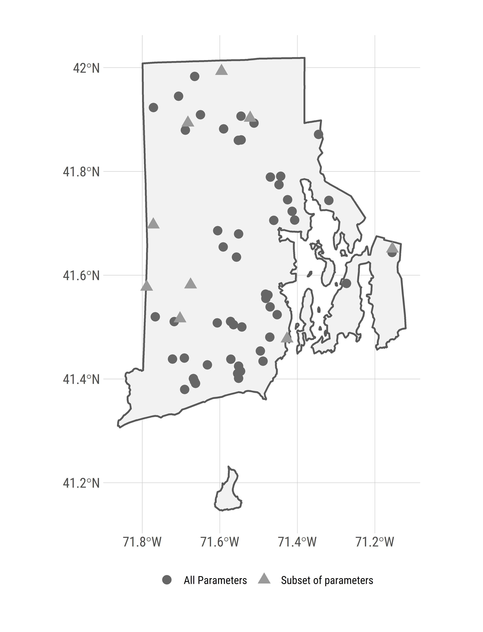 Figure 1: Map of URI Watershed Watch lake and reservoir sampling sites

###### 

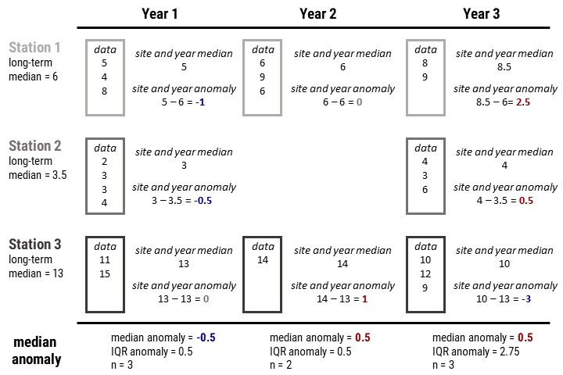 Figure 2: Example calculation of the site-specific anomalies and yearly median anomalies.

###### 

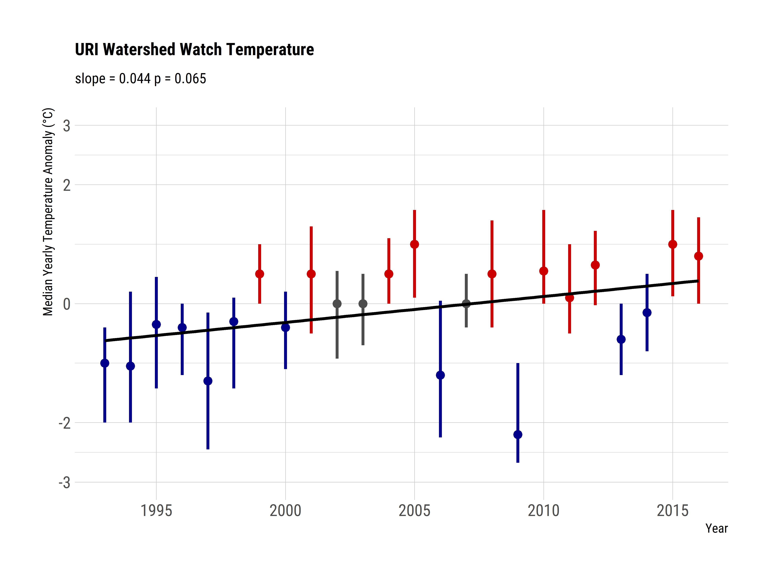 Figure 3: Yearly trend over 20+ years of lake temperature (median anomaly) in Rhode Island lakes and reservoirs. Points are medians of site-specific anomalies and ranges are the 25th and 75th percentiles of site-specific anomalies. Blue indicates yearly site-specific anomalies that were, on average, below the site-specific long-term medians. Red indicates yearly site-specific anomalies that were, on average, above the site-specific long-term medians.

###### 

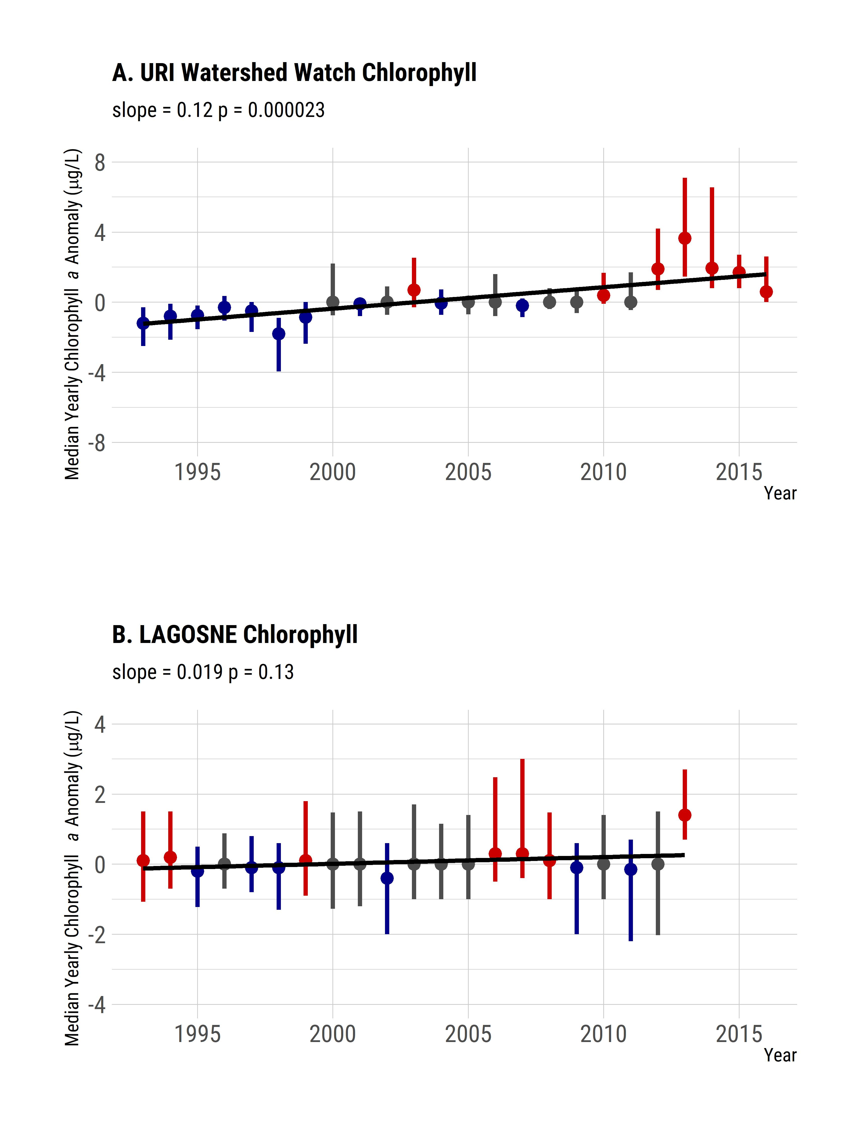 Figure 4: Yearly trend over 20+ years of chlorphyll a (median anomaly). Panel A. Yearly median chlorophyll a anomalies from the URI Watershed Watch data. Panel B. Yearly median chlorophyll a anomalies from the LAGOSNE dataset. Points are medians of site-specific anomalies and ranges are the 25th and 75th percentiles of site-specific anomalies. Blue indicates yearly site-specific anomalies that were, on average, below the site-specific long-term medians. Red indicates yearly site-specific anomalies that were, on average, above the site-specific long-term medians.

###### 

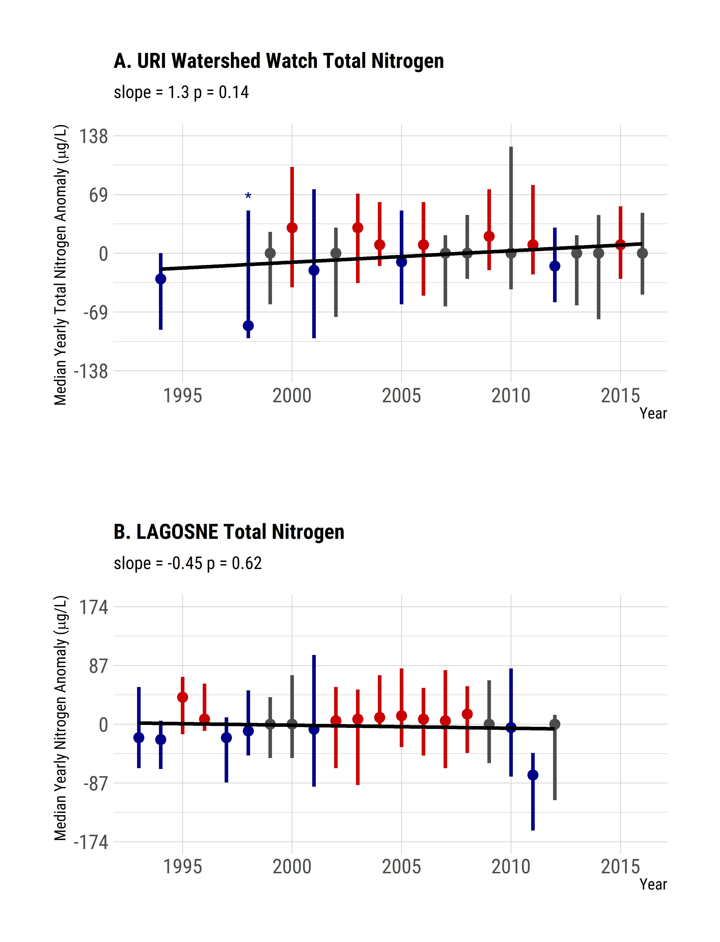 Figure 5: Yearly trend over 20+ years of TN (median anomaly). Panel A. Yearly median TN anomalies from the URI Watershed Watch dataset. Panel B. Yearly median TN anomalies from the LAGOSNE dataset. Points are medians of site-specific anomalies and ranges are the 25th and 75th percentiles of site-specific anomalies. Blue indicates yearly site-specific anomalies that were, on average, below the site-specific long-term medians. Red indicates yearly site-specific anomalies that were, on average, above the site-specific long-term medians. Grey indicates yearly site specifica anomalies that were, on average equal to the long-term medians. Missing years had insufficient data to calculate median and the 25th and 75th percentiles and an asterisk indicates year with only 3 sites and error bars are the range of the data.

###### 

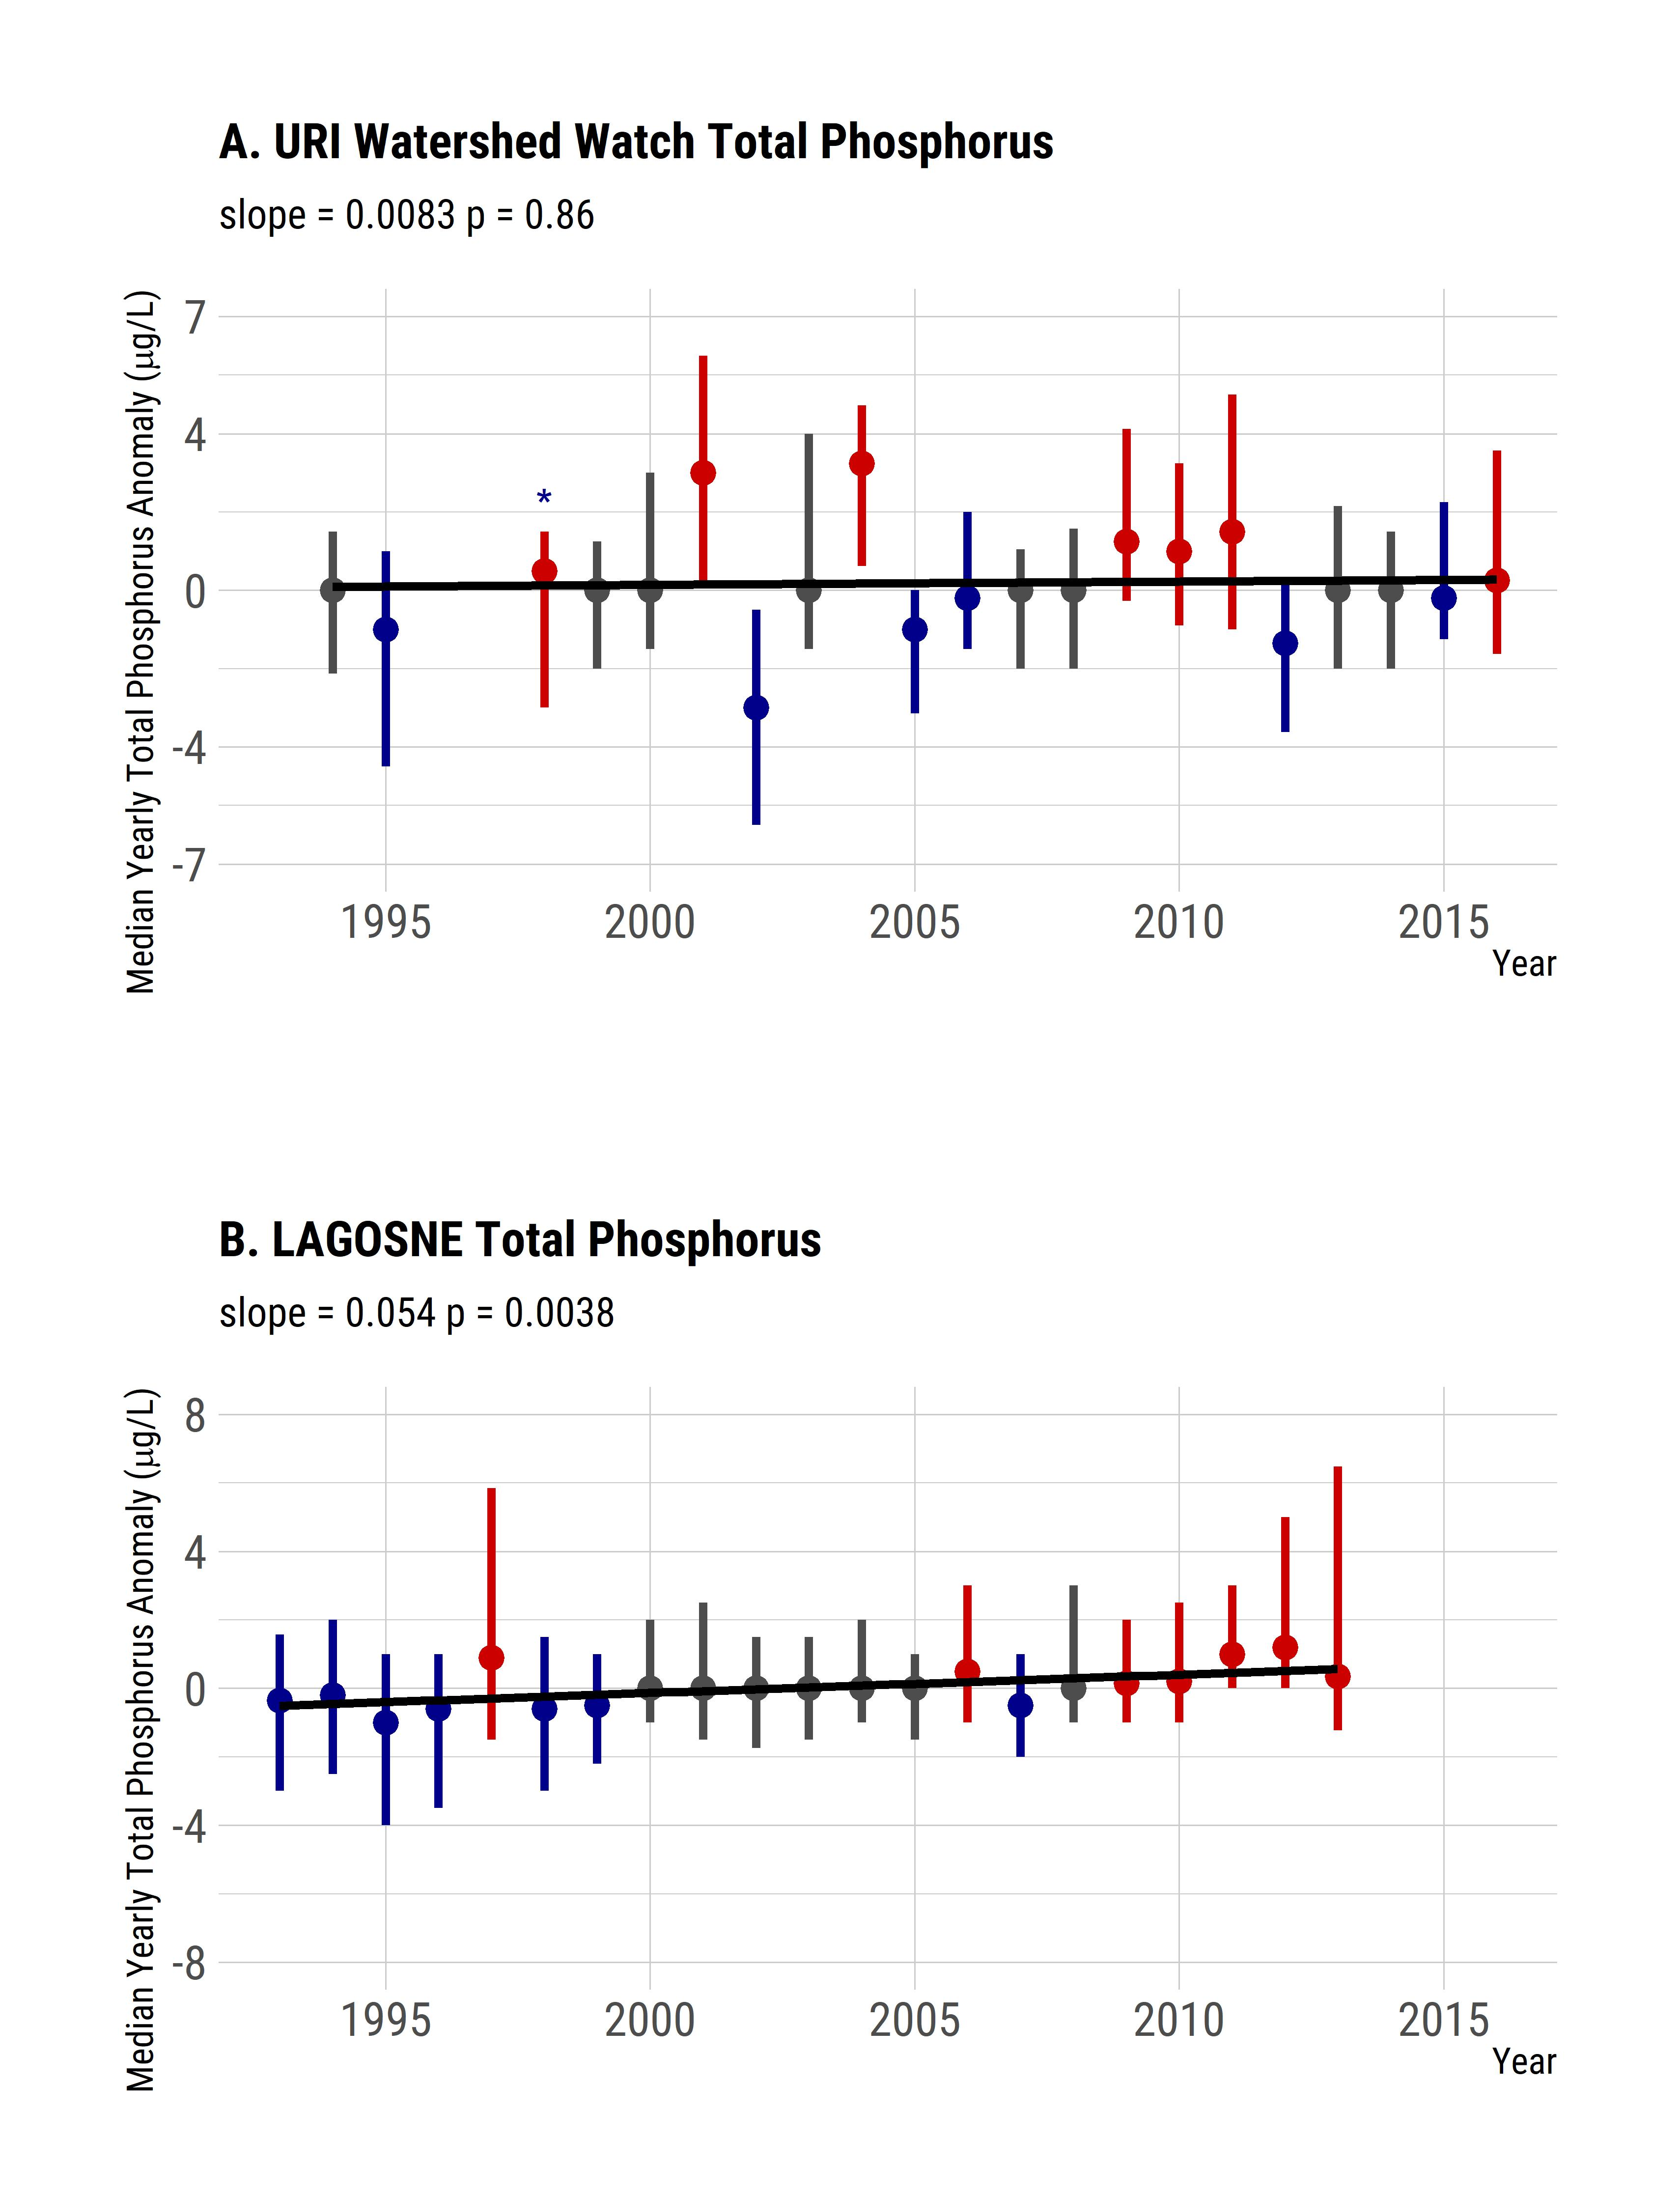 Figure 6: Yearly trend over 20+ years of TP (median anomaly). Panel A. Yearly median TP anomalies from the URI Watershed Watch dataset. Panel B. Yearly median TP anomalies from the LAGOSNE dataset. Points are medians of site-specific anomalies and ranges are the 25th and 75th percentiles of site-specific anomalies. Blue indicates yearly site-specific anomalies that were, on average, below the site-specific long-term medians. Red indicates yearly site-specific anomalies that were, on average, above the site-specific long-term medians. Missing years had insufficient data to calculate median and the 25th and 75th percentiles and an asterisk indicates year with only 3 sites and error bars are the range of the data.

###### 

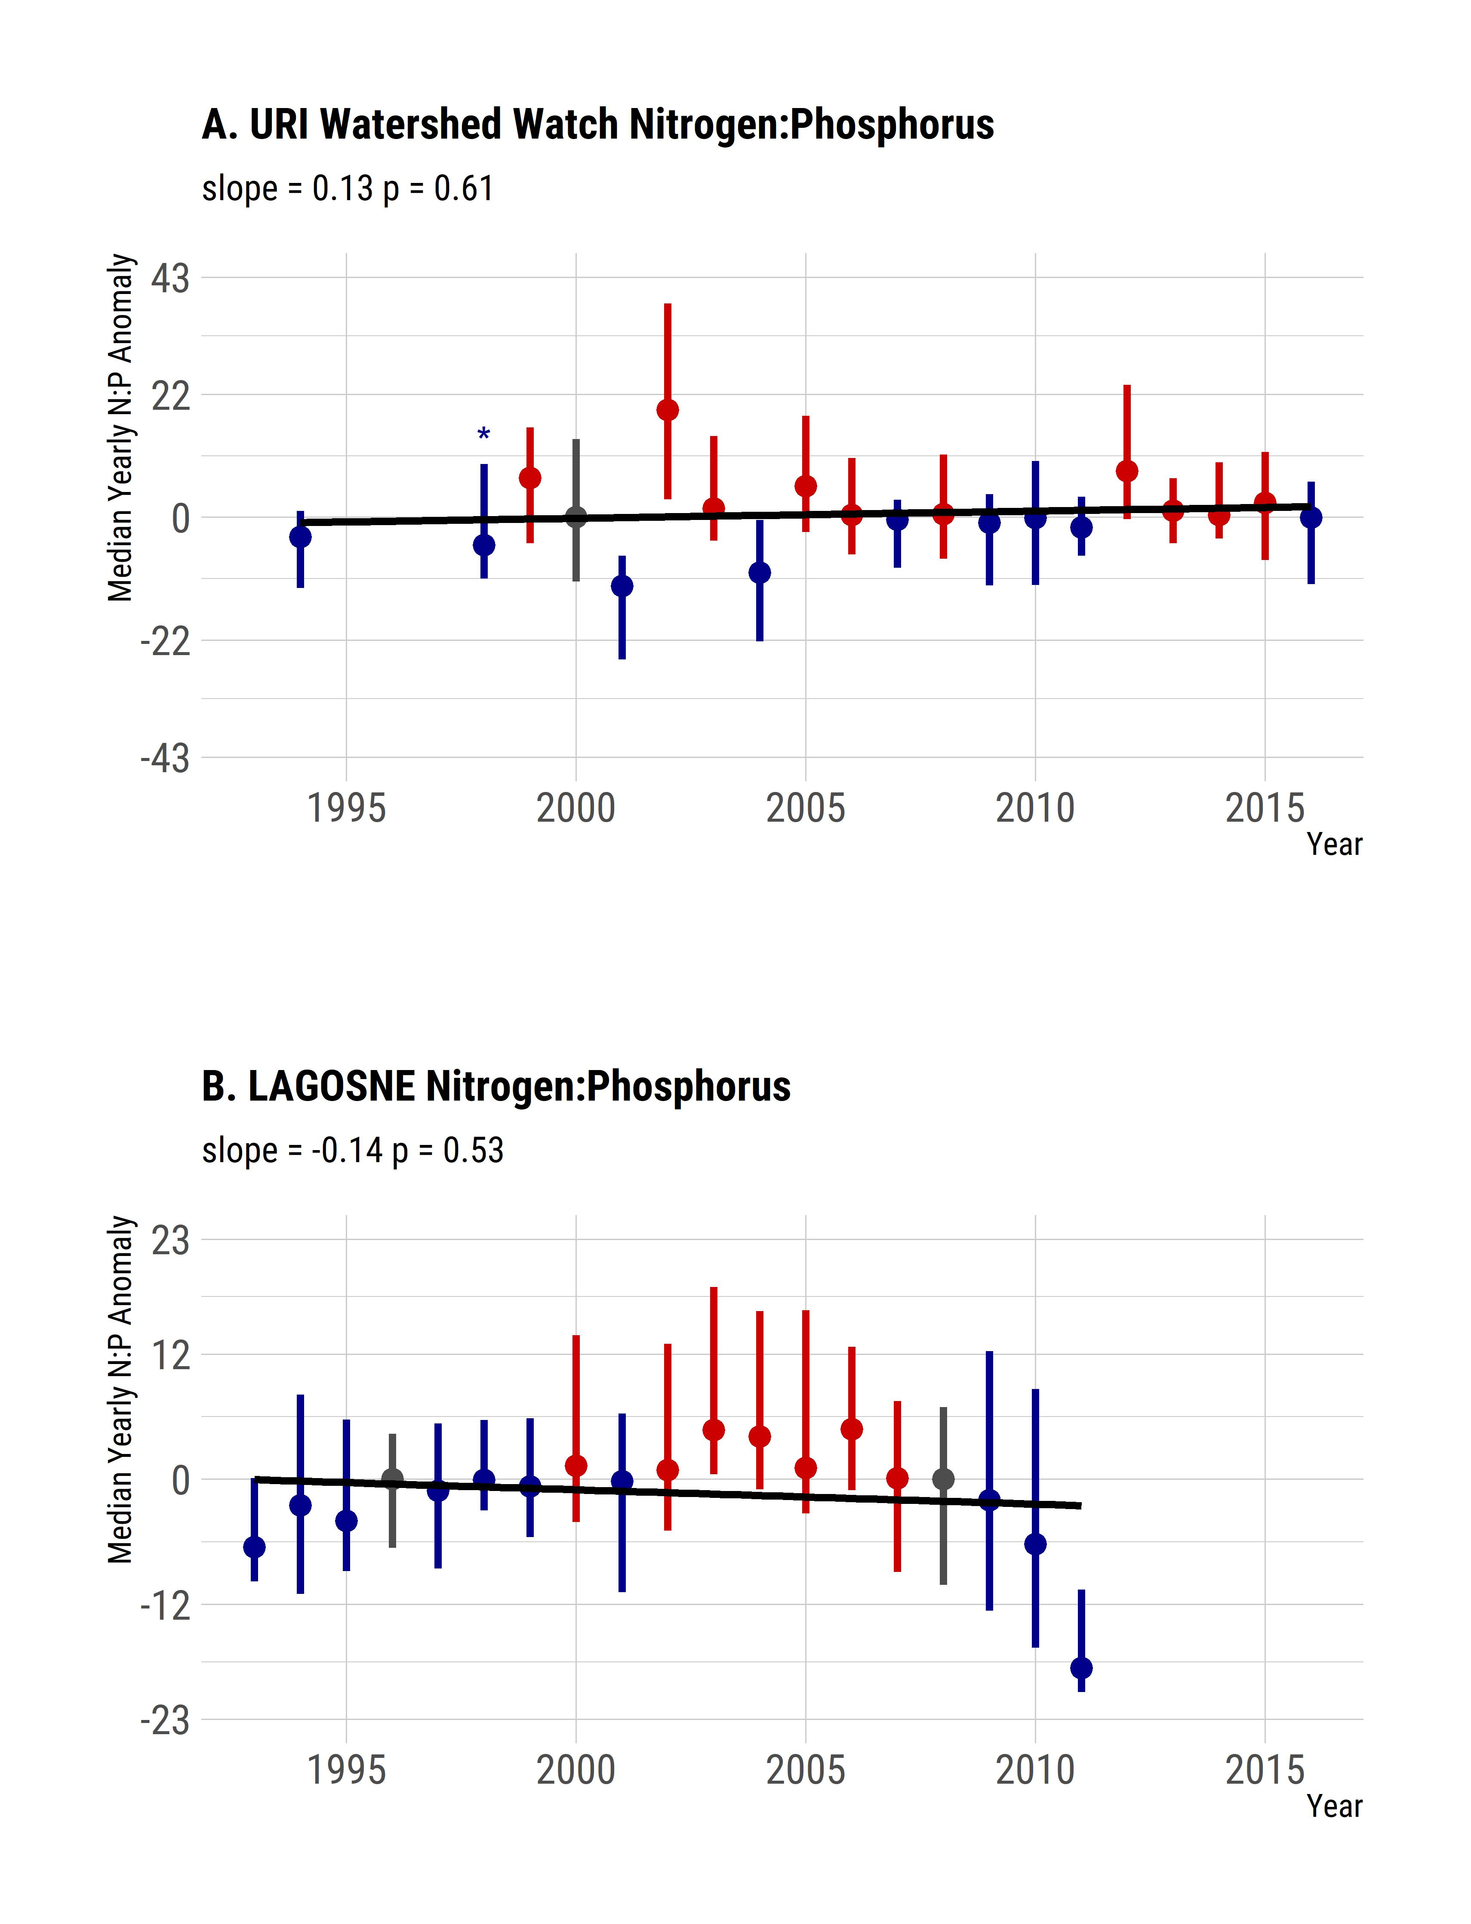 Figure 7: Yearly trend over 20+ years of the TN:TP ratio (median anomaly). Panel A. Yearly median TN:TP ratio anomalies from the URI Watershed Watch dataset. Panel B. Yearly median TN:TP ratio anomalies from the LAGOSNE dataset. Points are medians of site-specific anomalies and ranges are the 25th and 75th percentiles of site-specific anomalies. Blue indicates yearly site-specific anomalies that were, on average, below the site-specific long-term medians. Red indicates yearly site-specific anomalies that were, on average, above the site-specific long-term medians. Missing years had insufficient data to calculate median and the 25th and 75th percentiles and an asterisk indicates year with only 3 sites and error bars are the range of the data.

###### 

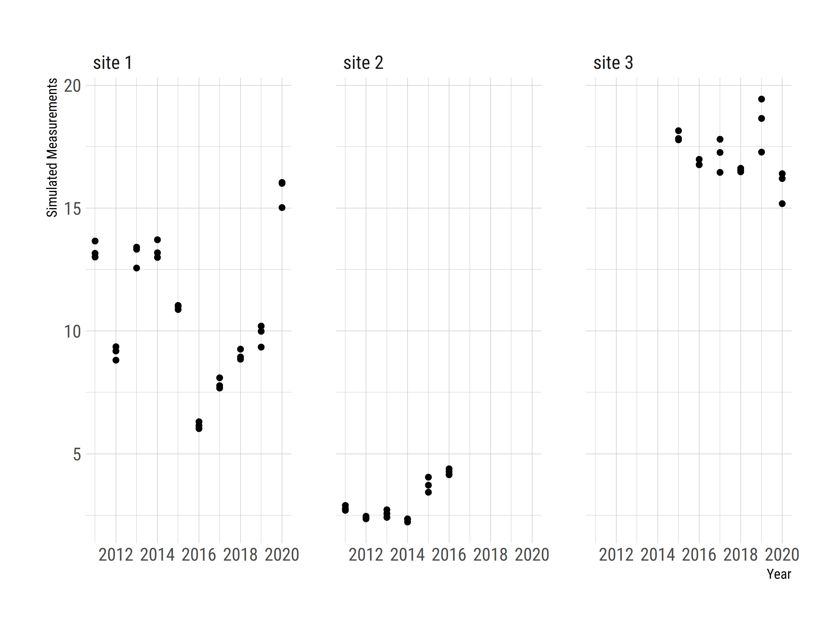 Figure 8: Simulated, random data showing example of sites with a low site early in a time preiod, a high site late in a time period, and one site measured across the time period.

###### 

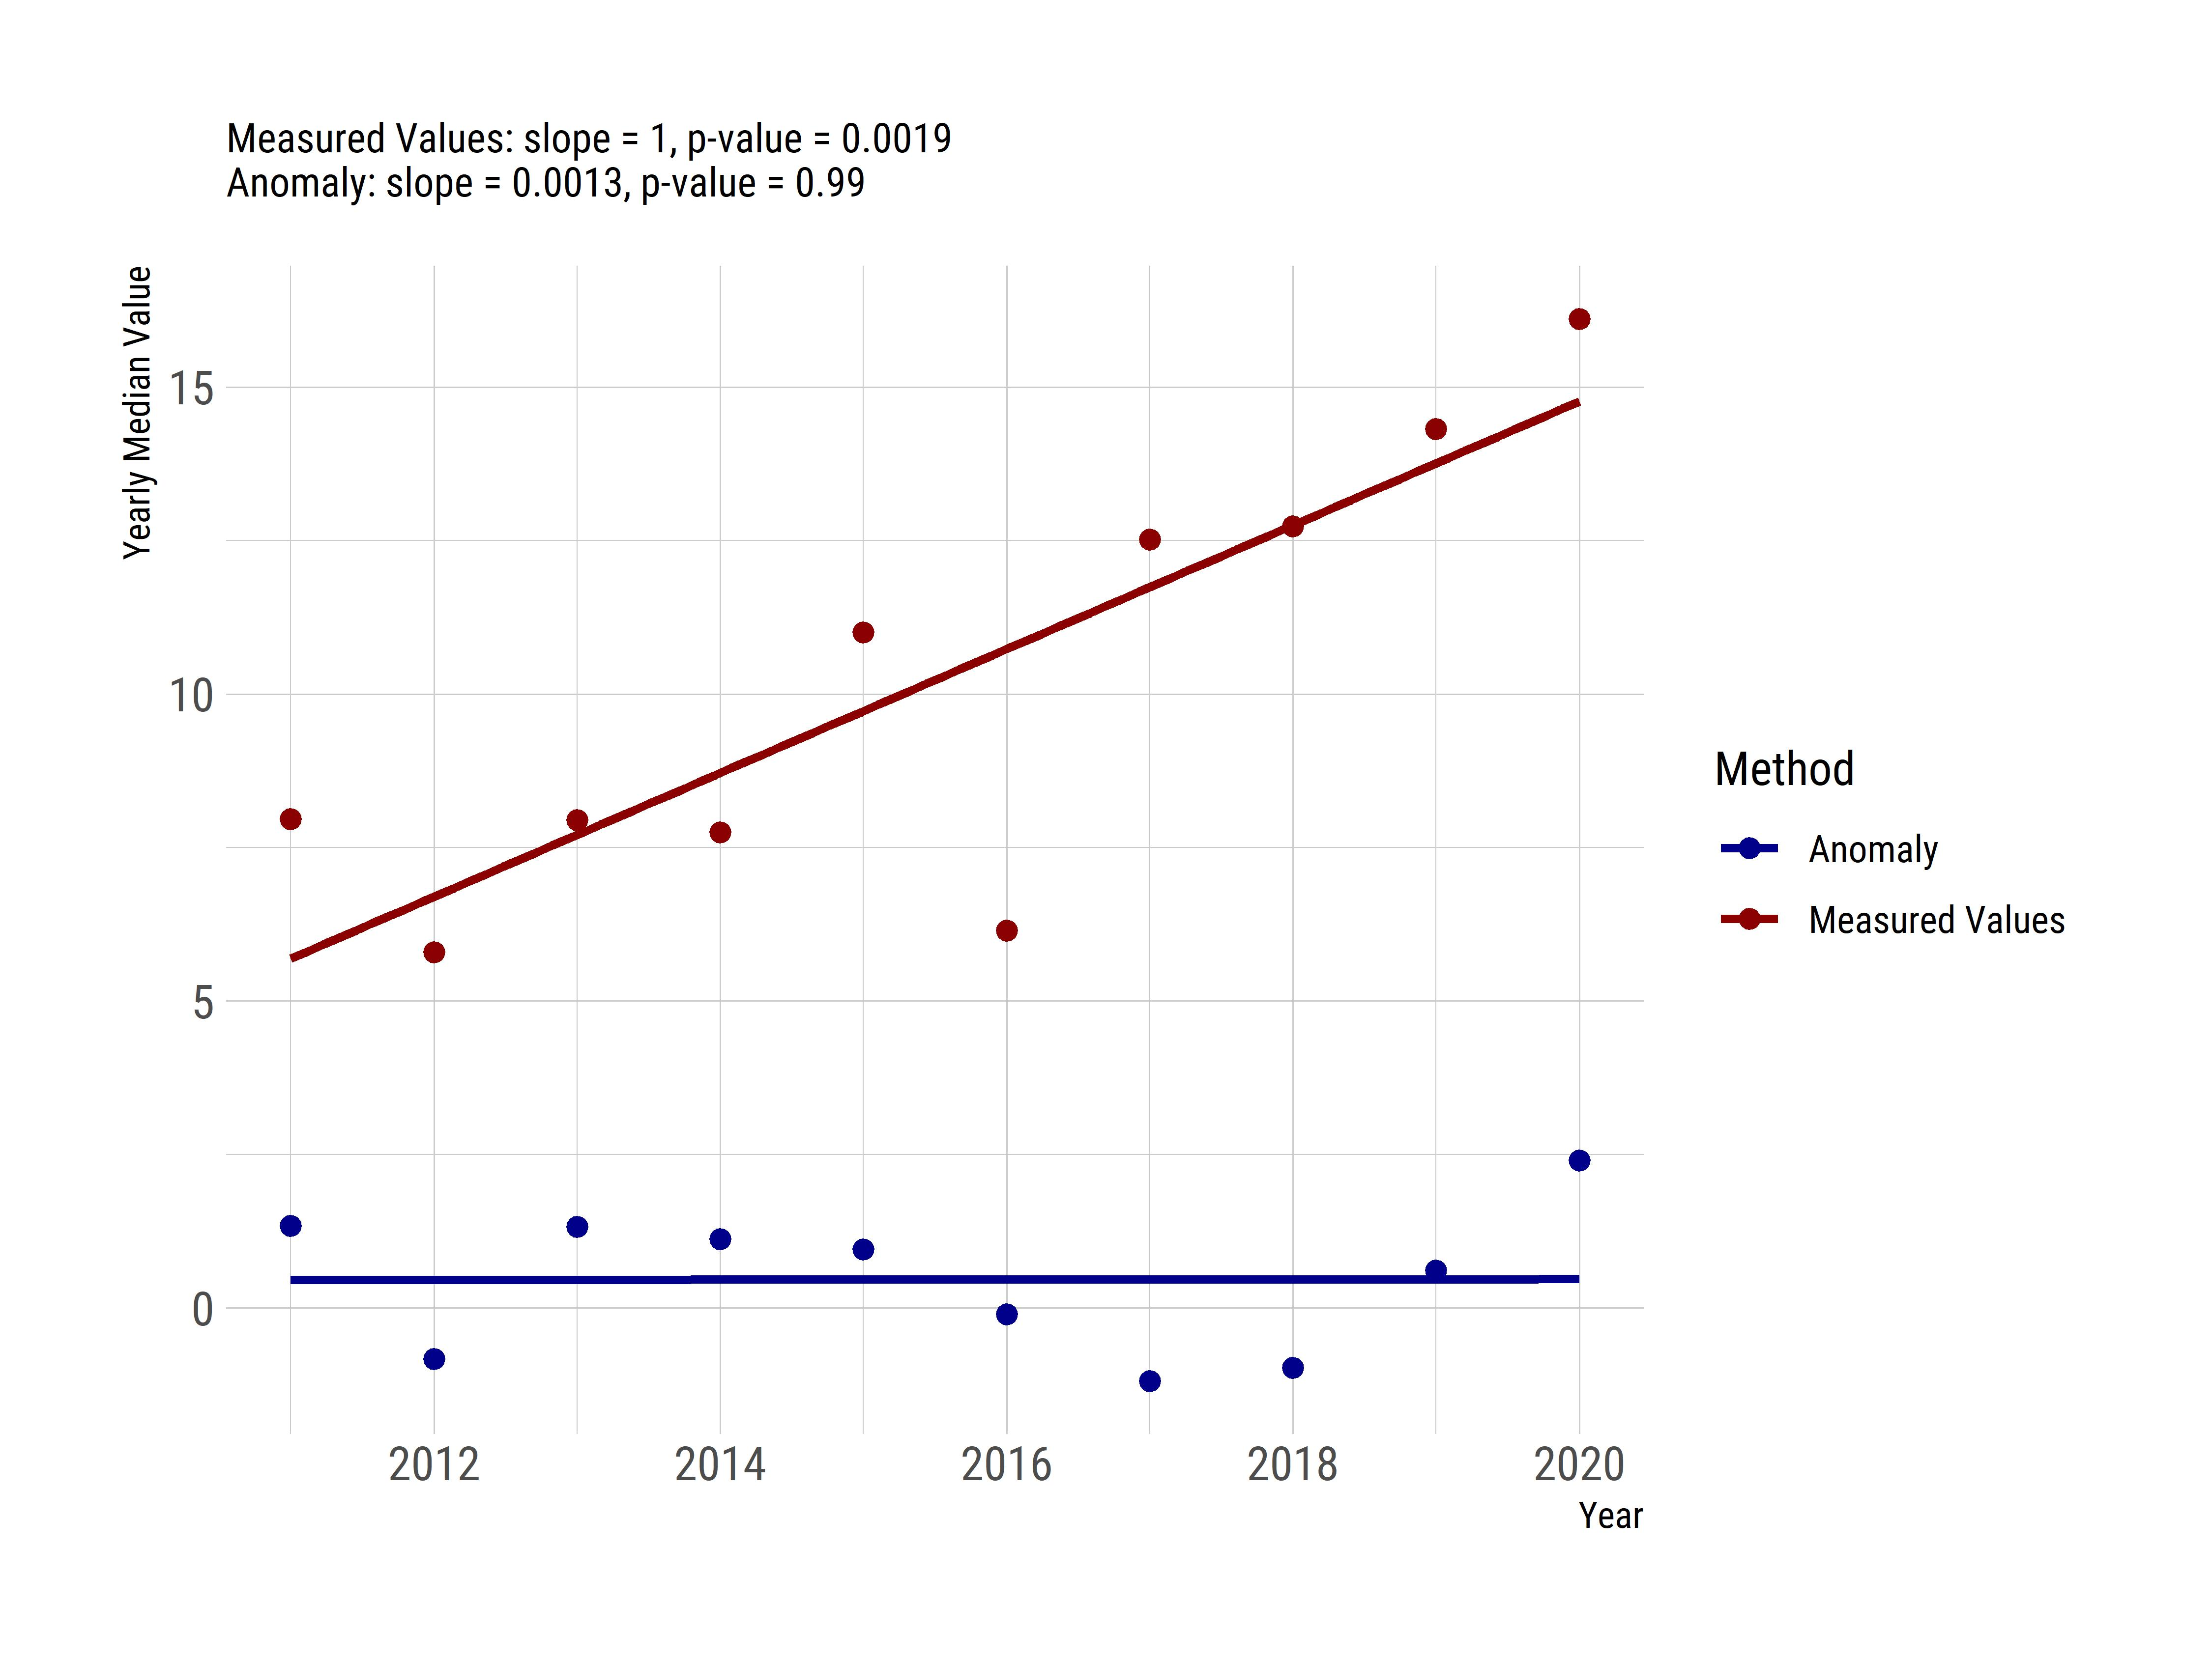 Figure 9: Analysis of simulated, random data with a low site early in a time preiod, a high site late in a time period, and one site measured across the time period. Yearly average of the actual values is shown in red and yearly average of the site-specific anomalies is shown in blue.